Declaration of Originality

We hereby declare that the solution submitted is an original work carried out by us. The ideas, implementation, design, and documentation presented in this submission are developed independently and have not been copied from any other source.
All third-party tools, libraries, APIs, frameworks, and datasets used in the development of this solution have been clearly identified, properly disclosed, and duly acknowledged wherever applicable. Any external resources used have been utilized strictly in accordance with their respective licenses and usage policies.
We further affirm that this submission does not violate any intellectual property rights and that all information provided is true to the best of my/our knowledge.

Signature of members

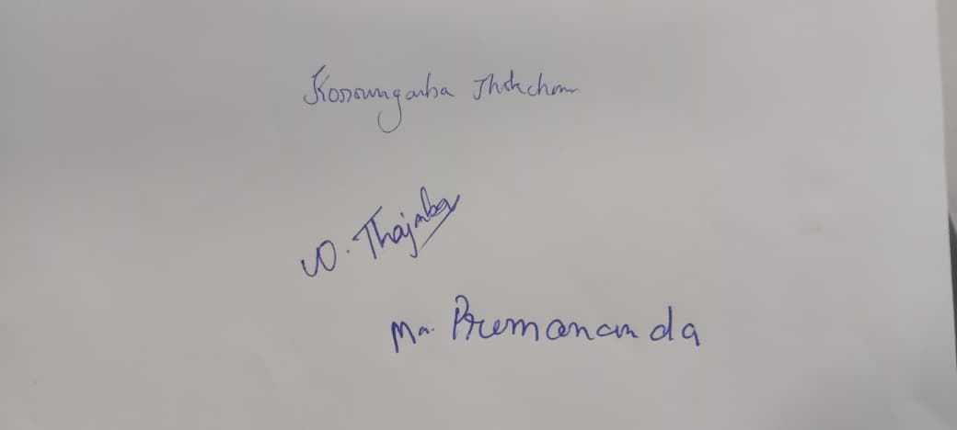
Front – end developer Model evaluator Back – end developer

